Central Tendency – IQR Analysis Report
Output Result:
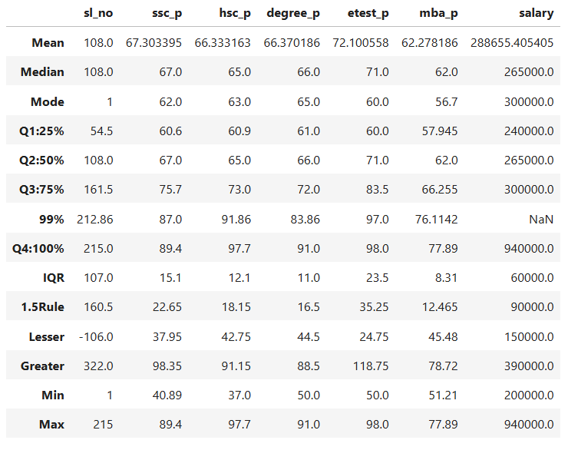

Summary of IQR Analysis

SSLC
- The Interquartile Range (IQR), calculated using the formula Q3 – Q1, is 15.1.
- The 1.5 Rule value, computed using the 1.5 × IQR, is 22.65.
- The Lesser Outlier Boundary, computed using Q1 − (1.5 × IQR), is 37.96.
- The Greater Outlier Boundary, computed using Q3 + (1.5 × IQR), is 98.35.
- The minimum SSLC mark in the dataset is 40.89, which lies above the lower boundary value of 37.96. Therefore, no lesser outliers are present in the dataset.
- The maximum SSLC mark in the dataset is 89.4, which lies below the upper boundary value of 98.35. Therefore, no greater outliers are present in the dataset.

HSC
- The Interquartile Range (IQR), calculated using the formula Q3 − Q1, is 12.1.
- The 1.5 Rule value, computed using the 1.5 × IQR, is 18.15.
- The Lesser Outlier Boundary, computed using Q1 − (1.5 × IQR), is 42.75.
- The Greater Outlier Boundary, computed using Q3 + (1.5 × IQR), is 91.15.
- The minimum HSC mark in the dataset is 37.0, which falls below the lesser boundary value of 42.75, indicating the presence of lesser outliers.
- The maximum HSC mark in the dataset is 97.7, which falls above the greater boundary value of 91.15, indicating the presence of greater outliers.

Degree
- The Interquartile Range (IQR), calculated using the formula Q3 − Q1, is 11.1.
- The 1.5 Rule value, computed using the 1.5 × IQR, is 16.5.
- The Lesser Outlier Boundary, computed using Q1 − (1.5 × IQR), is 44.5.
- The Greater Outlier Boundary, computed using Q3 + (1.5 × IQR), is 88.5.
- The minimum Degree mark in the dataset is 50.0, which lies above the lesser boundary value of 44.5. Therefore, no lesser outliers are present in the dataset.
- The maximum Degree mark in the dataset is 91.0, which falls above the greater boundary value of 88.5, indicating the presence of greater outliers.

Entrance Test
- The Interquartile Range (IQR), calculated using the formula Q3 – Q1, is 23.5.
- The 1.5 Rule value, computed using the 1.5 × IQR, is 35.25.
- The Lesser Outlier Boundary, computed using Q1 − (1.5 × IQR), is 24.75.
- The Greater Outlier Boundary, computed using Q3 + (1.5 × IQR), is 118.75.
- The minimum Entrance mark in the dataset is 50.0, which lies above the lower boundary value of 24.75. Therefore, no lesser outliers are present in the dataset.
- The maximum Entrance mark in the dataset is 98.8, which lies below the upper boundary value of 118.75. Therefore, no greater outliers are present in the dataset.

MBA
- The Interquartile Range (IQR), calculated using the formula Q3 – Q1, is 8.31.
- The 1.5 Rule value, computed using the 1.5 × IQR, is 12.465.
- The Lesser Outlier Boundary, computed using Q1 − (1.5 × IQR), is 45.48.
- The Greater Outlier Boundary, computed using Q3 + (1.5 × IQR), is 78.72.
- The minimum MBA mark in the dataset is 51.21, which lies above the lower boundary value of 45.48. Therefore, no lesser outliers are present in the dataset.
- The maximum MBA mark in the dataset is 77.89, which lies below the upper boundary value of 78.72. Therefore, no greater outliers are present in the dataset.

